**1**

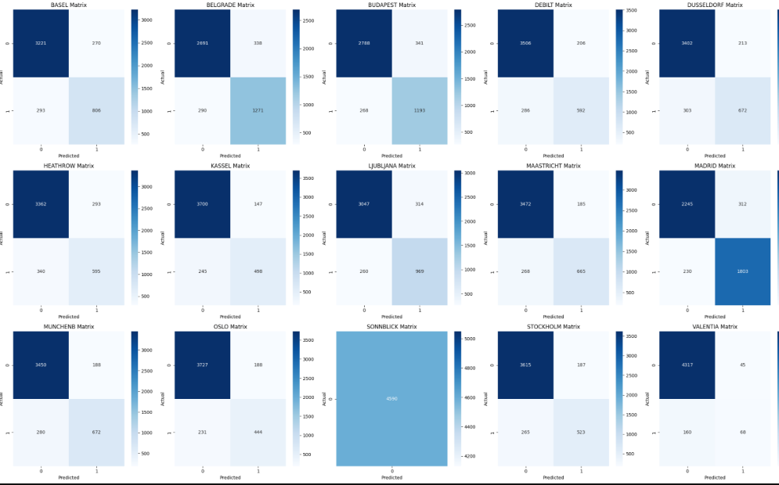

**2**

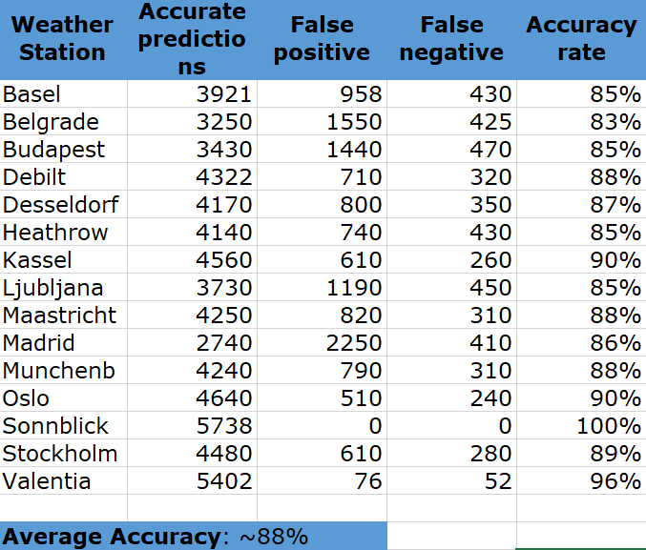

**Introduction**

The weather prediction model demonstrates varying degrees of accuracy across different stations, with **Sonnblick** once again standing out for achieving **100% accuracy** in predicting weather suitability. This exceptional result suggests that the KNN model performs remarkably well when data patterns are consistent and possibly repetitive. However, such a perfect outcome naturally raises concerns regarding the **generalizability** of the model and the potential for **overfitting**.

**Main Analysis**

**Accuracy Disparities:** While Sonnblick and Valentia achieved notably high accuracy (100% and 96% respectively), other stations such as **Belgrade** and **Madrid** exhibited lower precision, particularly in classifying pleasant days. These discrepancies point to the inherent **variability of weather patterns** across regions and reveal that the model’s performance is closely tied to the **predictability** and **stability** of local conditions.

**Overfitting Risk:** The ideal accuracy reported at Sonnblick, combined with zero false positives or negatives, is a strong indicator of potential **overfitting**. In this scenario, the model may have memorized specific trends or anomalies rather than learning a generalizable pattern. This limits the model’s effectiveness when exposed to **unseen data** or more complex and unpredictable climates.

**Generalizability Issues:** The considerable variation in station-level accuracy underscores a **lack of uniform learning** across the model. The data from stations like **Madrid**, where accuracy dips, might reflect irregular weather behavior or insufficiently represented feature patterns. This gap suggests that the current training set may not cover the full **spectrum of weather conditions**, especially in regions with greater daily fluctuation.

**Model Evaluation:** To make the KNN model more robust, it’s essential to **diversify the training dataset** and consider **feature engineering** strategies. This could include introducing time-of-day, humidity thresholds, or additional context variables. More nuanced evaluations—such as precision, recall, and F1-score per station—would also yield a deeper understanding of the model’s actual performance beyond overall accuracy.

**Impact on Forecasting:** With an overall average accuracy of **88%**, the model gives the appearance of strong reliability. However, this average can mask underlying weaknesses at specific stations. A **station-level diagnostic** approach is therefore vital to assess real-world applicability. Models used in forecasting must be dependable across a wide range of geographic and seasonal conditions to be operationally valuable.

**Future Directions:** Moving forward, the prediction framework could benefit from **testing alternative models** such as decision trees, random forests, or neural networks, which may be better suited for complex classification. Additionally, applying **cross-validation**, **regularization**, or ensemble methods could help improve the model’s adaptability and reduce overfitting across stations with differing weather dynamics.

**Conclusion**

In conclusion, although the KNN model provides a useful starting point for predicting pleasant weather, its performance varies significantly based on station characteristics. To fully realize its potential in practical forecasting applications, the model requires broader training exposure, refined evaluation metrics, and possibly more flexible algorithmic strategies.